## Activity 1: Treadmills

Mai and Jada each ran on a treadmill. The treadmill display shows the distance, in miles, each person ran and the amount of time it took them, in minutes and seconds.

Here is Mai’s treadmill display:

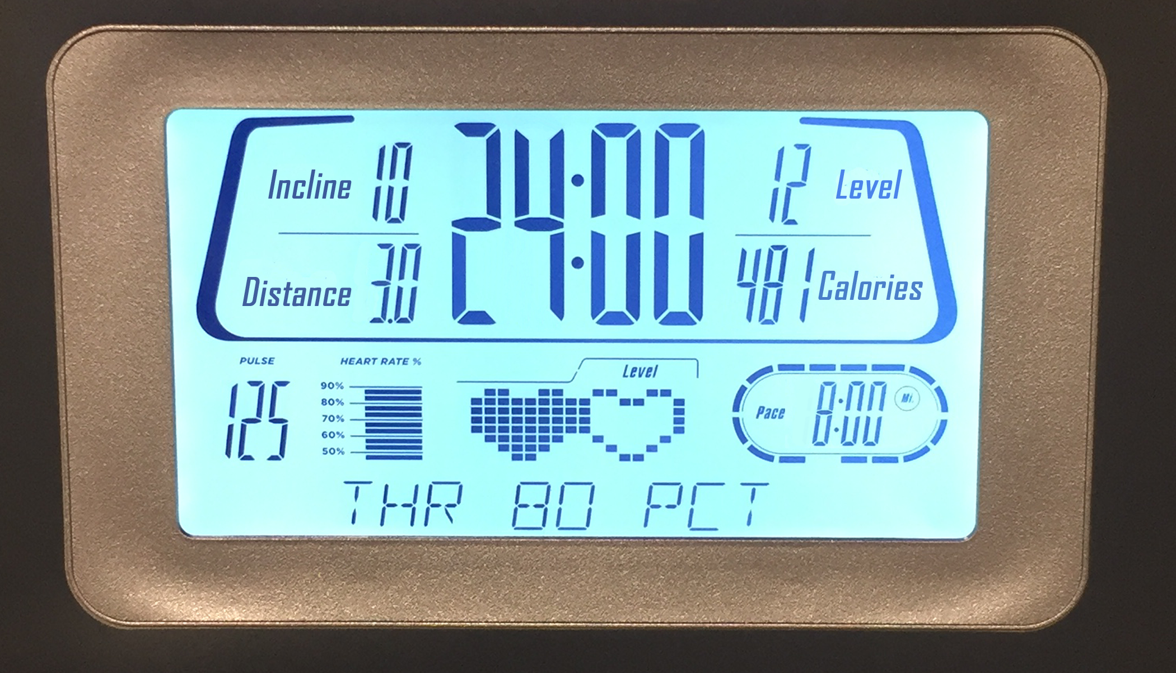

Here is Jada’s treadmill display:

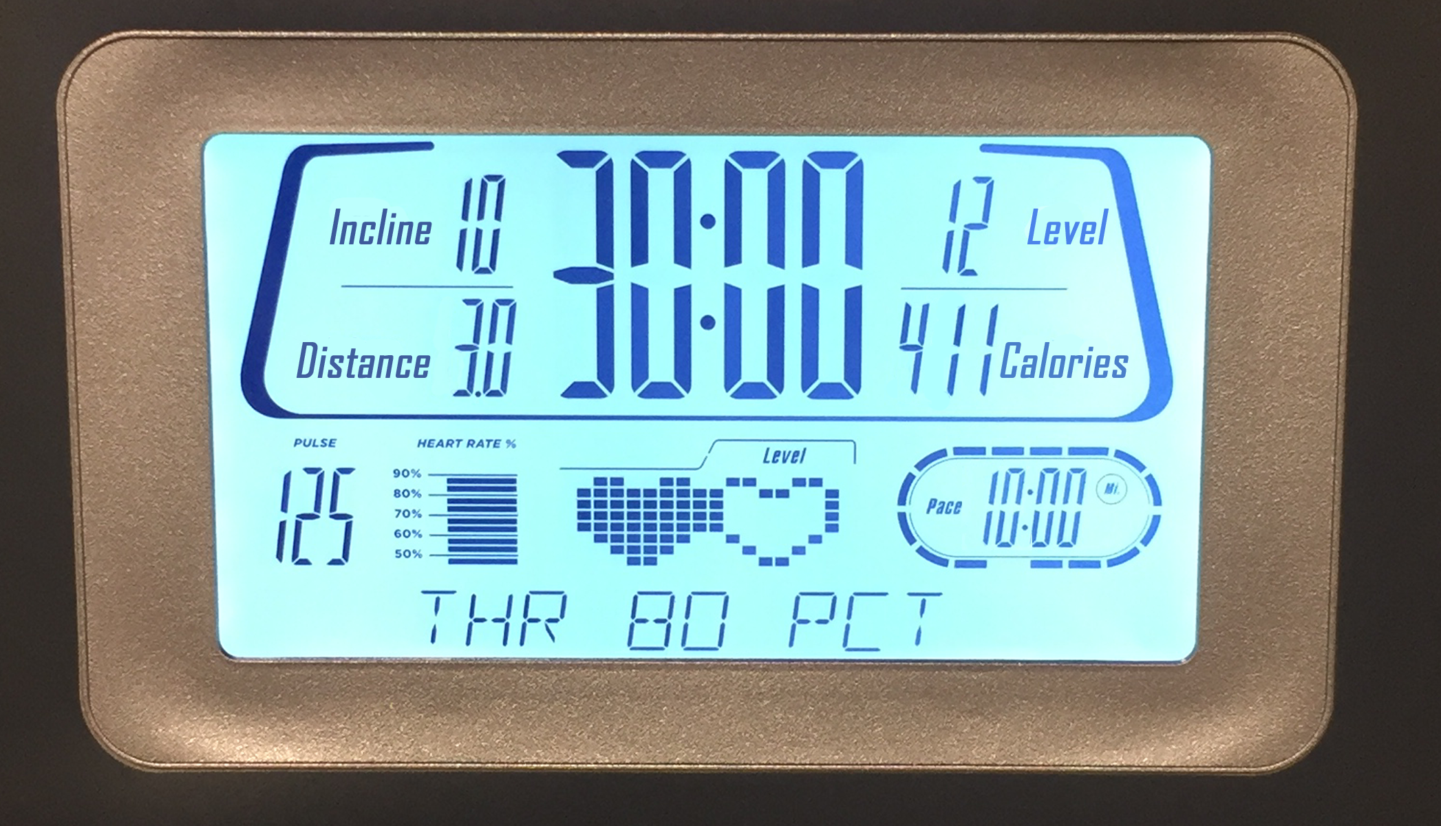

1. What is the same about their workouts? What is different about their workouts?
2. If each person ran at a constant speed the entire time, who was running faster? Explain your reasoning.



© CC BY Open Up Resources. Adaptations CC BY IM.